Subaward Reference Guide

Table of Contents
Introduction 1
Find A Subaward in Workday 1
Basis Limit 3
IDC charges 4
Invoice Processing 5
Troubleshooting Invoice Processing 7
Subaward Modifications 8

Introduction
In Workday, each subaward on an award has its own grant line and its own GR number. Internally, subawards are created in Workday as a Supplier Contract. Subaward Supplier Contracts behave differently from non-subaward (i.e. vendor) supplier contracts. Workday only allows payments on Supplier Contracts during the active period of the contract. (Note: this is a Workday feature that the University has no ability to change.) Therefore, in order to process invoices past the contractual subaward end date for work completed within the period of performance, the Subaward Supplier Contract end date in Workday is set to 90 days past the actual subaward end date. This is purely an internal mechanism to ensure invoice processing can occur after the period of performance has ended, but does not affect the period of performance of the sub. A note about this end date is in the process history tab of the Subaward Supplier Contract record.

The subaward period of performance dates are in Kuali Research (KR) and in the subaward document itself.

To ensure you are using the most recent version of this guide, please refer to the online version here (rather than the emailed PDF).

Find A Subaward in Workday
Search either by grant worktag (e.g. GR010327) or supplier (e.g. Vanderbilt University) using “RPT893 Find Supplier Contracts for My Organizations.”

From this report, you can also see the invoices processed on that GR and click through to see the invoice details. Only invoices processed after Nov 15, 2024 (Workday go-live) will show up in this list.

To find the details of a subaward and the corresponding Subaward Supplier Contract from within a particular Award, find the award in Workday. Once in the Award Overview screen, select the Award Lines tab and then locate the subaward line. Click the three horizontal dots next to the magnifying glass icon for the subaward line to show additional details on the subaward line. From there you can locate the Subaward Supplier Contract number and, if you have the Grant Manager security role, can click directly into the Subaward Supplier Contract. If this view is not available to you, it is likely due to your security roles. You should still be able to use RPT893 noted above.

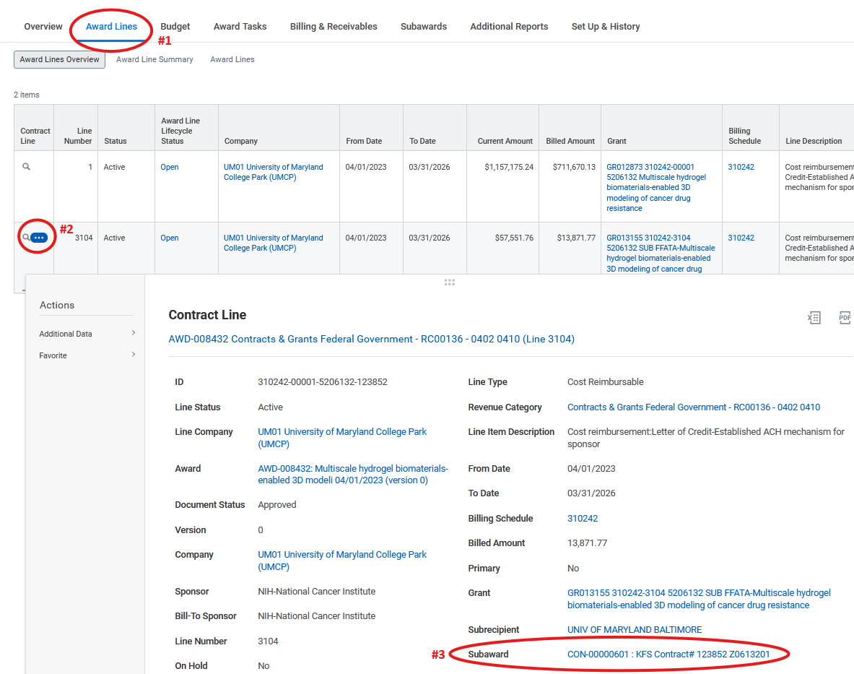

Workday assigns subaward supplier contracts a CON number (e.g. CON-12345678). To see this number in KR, navigate to the Financial tab in the subaward record and look for the “Purchase Order ID” field. The full subaward number in WD is CON-12345678; in KR it will be reflected as 12345678 (i.e. without the “CON-” prefix).

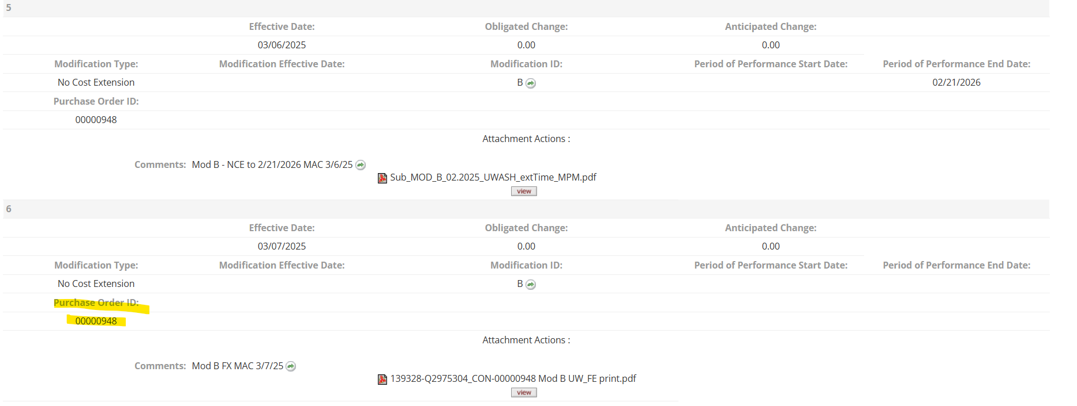

Basis Limit
On Federal awards and non-Federal awards that use the MTDC indirect cost rate base, indirect costs are charged on the first $25,000 of each subaward. In KFS, this was managed using two different object codes (3732 which was subject to IDC and 3734, IDC exempt). In Workday, this is managed using a basis limit.

There are two ways to see the basis limit on a subaward.
- Click on the Award Lines tab on the award header to see the grant lines, and scroll to the right to the basis limit column.

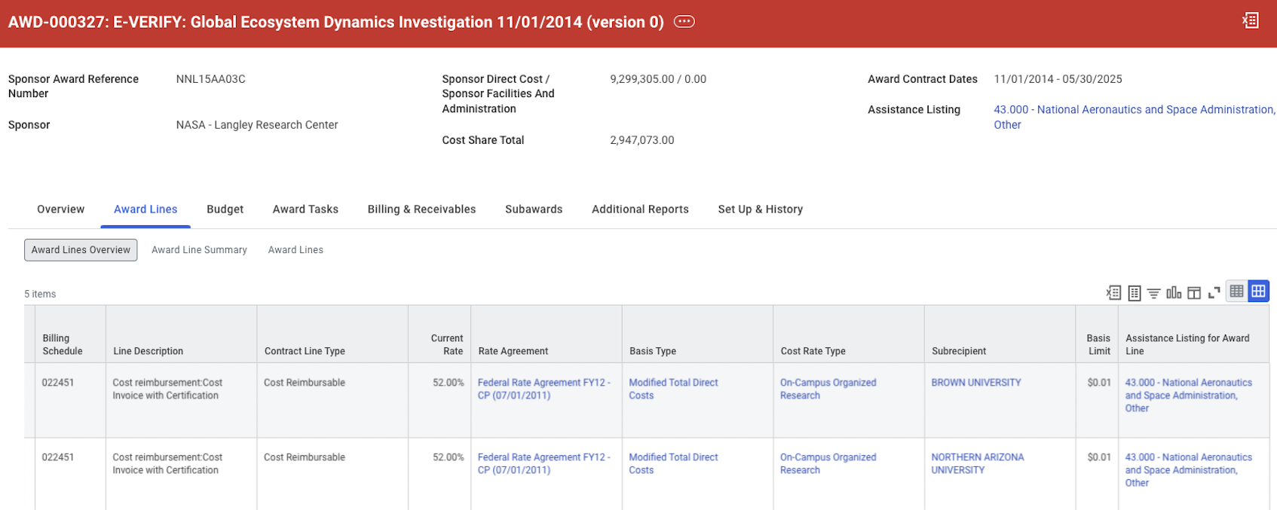

- Click on the Subawards tab on the award header, and then the Basis Limit button. (The “Maintain Subawards” screen is only available to ORA and SPAC.)

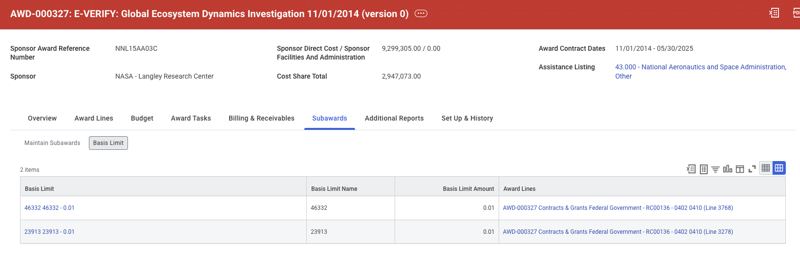
A basis limit of .01 in Workday means this is a converted award where the amount subject to IDC has already been reached. A basis limit of anything other than .01 or 25,000 is likely an artifact of the transition from KFS to Workday. The subaward team will update the basis limit as new modifications are made to the subaward. New awards are set up with a basis limit of $25,000 regardless of the initial funding amount.

Workday also includes a “shared basis limit” feature. Occasionally, large, multi-institutional grants and cooperative agreements contain multiple subawards to one entity. In these cases, a single basis limit can be applied to that group of subawards.

IDC charges
Award budgets in Workday are set up at the award header (AWD) level, and not on the award line / grant worktag. (The only exception to this is for converted awards which may have a budget for both parent and child accounts.)

The indirect costs charged on top of subaward invoices will follow the subaward and therefore hit the subaward grant line. Importantly, however, the indirect costs will NOT post against the Subaward Supplier Contract itself.

For converted awards or those set up in Workday prior to this notice, IDC for the subaward was likely included in the parent GR line. Because of this, Workday reports like RPT314 may show an overspend on the subaward GR line (due to the indirects hitting that line) and an underspend on the parent GR line (due to the budget for indirects on top of subawards being included in the parent line).

If this is the case, departments may request a budget change using the ORA Post-Award Management Request form. The KB WD Budget template has been updated to include a field for the indirects on top of the subaward costs separate from the broader IDC field and to allow for parent/child/subaward GR ID object class details. PIs/departments may request a more detailed object class budget for all of an award’s grant lines using the ORA Post-Award Management Request form. This will allow future budgets entered into WD to assign the direct and indirect costs to the parent, child, and subaward lines which will more closely align with the expected expenses. Departments may also incorporate this KB WD Budget into their departmental budget templates so that the details are included at time of routing.

REMINDER: for sponsored projects, the budget in Workday is based on either a) the budget included in the award notice, or b) an updated KB WD Budget by object class (submitted via the ORA Post-Award Management Form). The Award amount is the amount the sponsor has obligated to UMD as recorded in KR as the “Obligated Dollars,” less amounts subawarded to other organizations, and is updated as sponsor funding changes or if funds are transferred between related accounts. The budget does not affect spending limitations and is used for internal monitoring and reporting purposes.

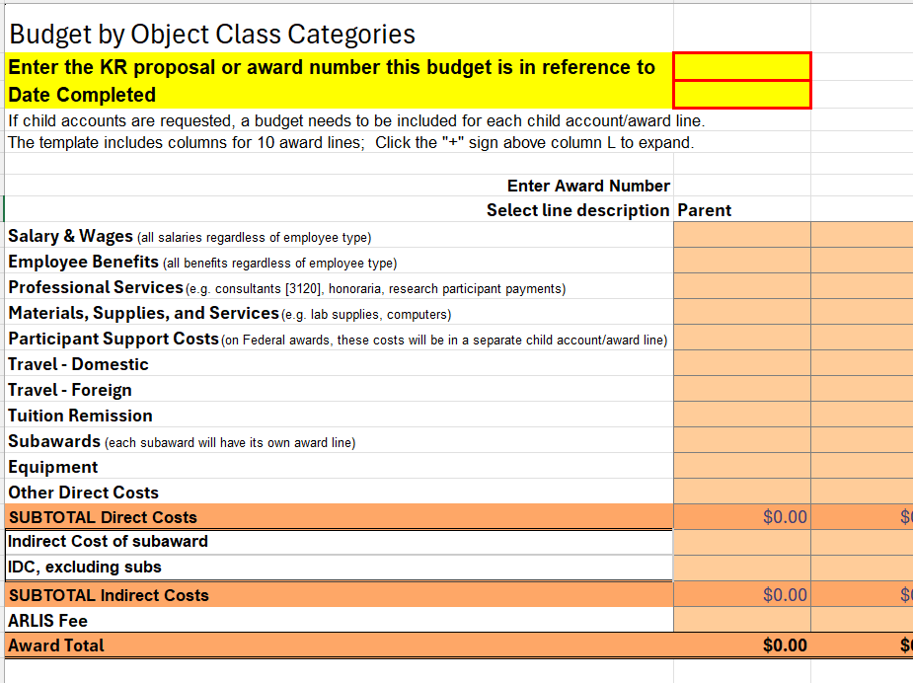

Invoice Processing
Accounts Payable loads invoices received at apadmin@umd.edu into Workday. Subaward invoices route to the Grant Manager (GM) and the PI for approval. GMs can delegate this task to the research coordinator managing the project.

The Review & Approve Supplier (Subaward) Invoice job aid contains technical information about the process for approving invoices. RPT689 can be used to find invoices for a particular supplier (aka subawardee). For Federal award, review the Job Aid for the certification language required on subaward invoices.

The subaward supplier invoice task is sent to the GM with the following notification:
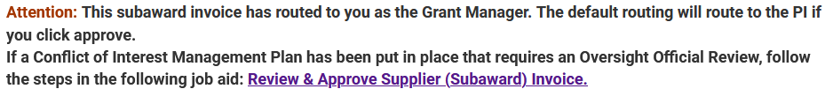

GMs should review the financial accuracy of the subaward invoice and approval constitutes an attestation to the following:
- The invoice includes the complete subaward number and the subrecipient’s Federal ID number;
- The amount invoiced represents work performed during the subaward period;
- Current and cumulative amount totals are accurate and within the subaward obligation;
- The costs claimed are, to the best of your knowledge, in accordance with the requirements of the subaward, comply with applicable budgetary restrictions and Uniform Guidance rules on allowability of costs, and that the funds are being utilized for authorized purposes;
- There are no substantive deviations from the approved budget that would indicate an unapproved change in scope;
- Subrecipient has met any cost sharing requirements and provided requisite supporting documentation; and
- The invoice includes the appropriate certification statement and is signed by an authorized official at the subrecipient organization.

During this review, the GM may upload additional attachments to the invoice record. Additional attachments may include the Subrecipient Monitoring Invoice Checklist found on ORA’s website, clarification requested/received from the subawardee, reference and tracking information, and/or email affirmations from the PI regarding technical progress or additional notes. If attaching an email, that email should include the following information:
- Invoice number
- Subawardee
- UM GR number
- Invoice amount
- Claim period

Backup documentation added to the invoice record may be sent to the State of Maryland during the review and payment process so units should be intentional and judicious about what is uploaded to the system of record. The add attachment process can also be used to replace the invoice if a newer, updated one has been sent by the subawardee. The GM should upload the new invoice and then must send the task back to Accounts Payable with comments so they can correct the data typed directly into Workday.

Below is information on how to add attachments to the invoice record. This functionality is automatically available to the Grant Manager, not the delegates. If delegates should have access to upload or change attachments, use Service Now to request that security role “Supplier Invoice Attachment Uploader.”

To add an attachment: from the inbox task, click the three horizontal dot button next to the supplier invoice number, then click the supplier invoice number at the top of the resulting pop-up window to view the full invoice.

On the View Supplier Invoice screen, click the three horizontal dot button next to “Supplier Invoice (magnifying glass),” then click Supplier Invoice -> Add attachment.
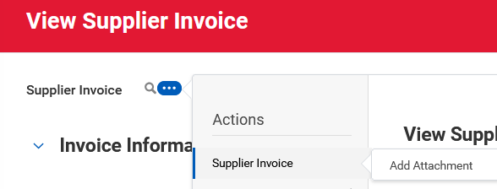

From there, the GM can click upload to add an attachment. This new attachment will show up in the task after it is added and will remain in the record after approval.

NOTE: The Subaward Invoice Attachment Uploader must attach backup documentation in Workday as themselves before switching to act as the delegate of the GM to approve the invoice.

After the GM or delegate approves the invoice, it will automatically route to the PI. The PI should review the invoice to ensure the costs are reasonable and commensurate with the work performed during the invoice period.

If the PI has a Conflict of Interest Management Plan that prohibits them from approving subaward invoices, the GM should have the PI review the invoice outside of Workday to ensure it is commensurate with the work performed. Then, before approving, the GM must click the “Add Approvers” button, choose the “COI Oversight Official” role, and add the relevant oversight official to add to the process. After that, when the GM approves the invoice, it will route to the oversight official instead of the PI.

The subaward supplier invoice task is then sent to the PI for approval with the following notification:
Action Required: The below invoice has routed for your approval because it is tied to a Subaward Supplier Contract. All invoices against a Subaward Supplier Contract require Principal Investigator approval.

In clicking approve below, I authorize payment of this invoice and attest that the charges appear reasonable and progress to date for this project is satisfactory and in keeping with the statement of work.

Both the GM and PI have the authority to reject invoices if work has not been completed satisfactorily.

Troubleshooting Invoice Processing
There are a few reasons why A/P might not be able to process a subaward invoice.
- Lack of funding on a supplier contract line:
  - Review KR to ensure modifications have been requested and processed, especially for incrementally funded subawards. Invoices cannot be processed until the modification has been executed by both UMD and the subawardee.
  - Request that A/P review the available balance on the subaward. Occasionally, invoices are processed by UM but not sent by the State, or money was returned by the subawardee, and this affects the apparent available balance of the subaward. If that is the case, email ORAERA@umd.edu and they can make corrections on the back end to correct the available balance and allow the invoices to be processed.
- Expiration date:
  - Review KR to ensure modifications have been requested and processed, especially for incrementally funded subawards. Invoices cannot be processed until the modification has been executed by both UMD and the subawardee.
  - Review the GR end date in Workday with the subaward record in KR. If either do not match the subaward, contact orasubaward@umd.edu to have the expiration date adjusted and have the account marked as open instead of closed.
- Vendor record:
  - Some vendors did not convert properly at Go-Live. If this happened, the subawardee may have been re-entered into Workday as a new vendor. This means the original PO (now CON) would have been cancelled and a new one issued.
  - See the Find A Subaward section of this document for instructions on how to find the CON number in KR. Ensure your subawardee also has this new number for future invoices.

Subaward Modifications
All formal subaward actions (adding time and money, deobligating funds) are processed through the ORA subaward team (orasubaward@umd.edu). Forms for establishing and modifying subawards can be found on ORA’s website. The subaward team controls entry of time, amounts, etc., into the KR Subawards module which is the system of record for subaward agreements. The Workday GR line for the subaward is dictated by the actions processed in KR; e.g. when more money is added to the subaward in KR, the overnight feed from KR to Workday will move the funds from the parent GR line to the subaward GR line. Once this feed has processed and the subaward document has been fully executed, the subaward team will finalize the subaward supplier contract.

NOTE: The subaward modification moves “current amount” funding, but does not affect the budget in Workday. The budget amount is updated by the Award Administrator in ORA at the time the award is set up or new money is added to the account. If the budget is incorrect, use the Post-Award Management Request form in Kuali Build to request a correction.

When a subawardee’s work is done and final billing is complete, departments should use the Post-Award Management Request form to deobligate remaining subaward funds to have those released back into the parent GR line.

